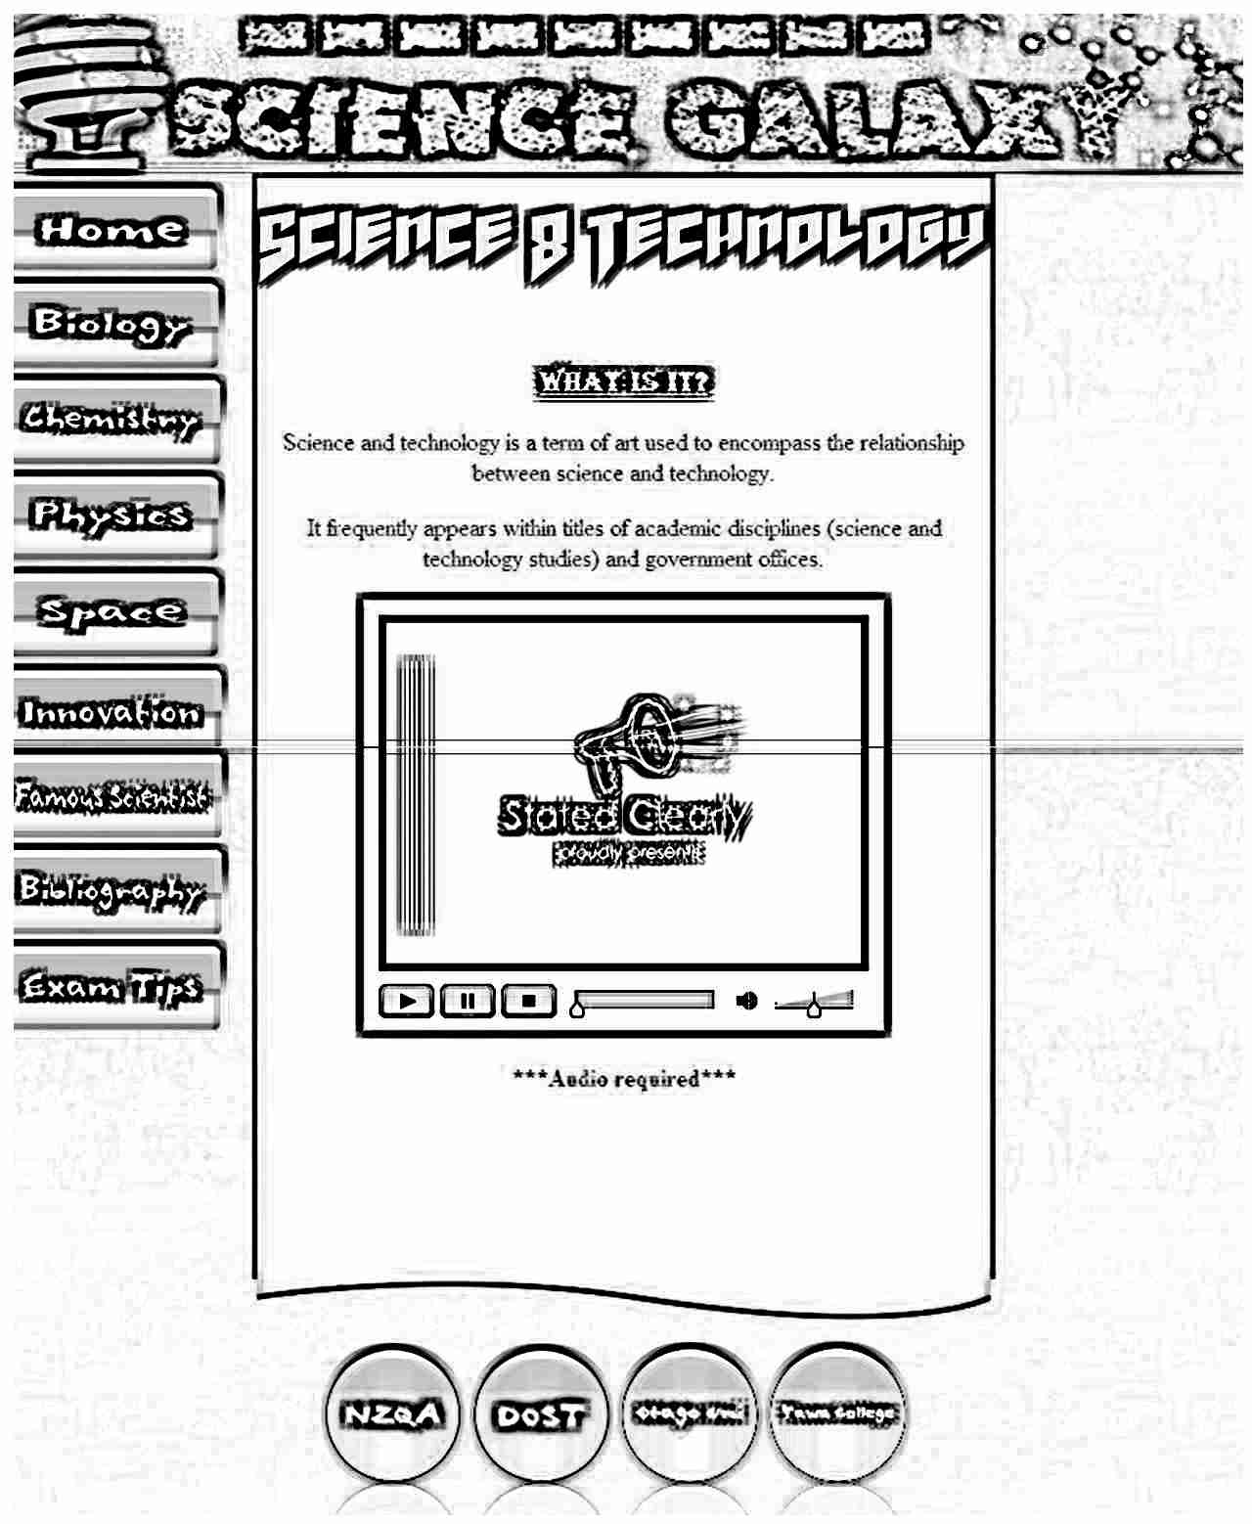
Website Banner
Babelfish, back:#006496, text colour: #fffff, 151x63, 55 px
Pandora limiter, 80px, #fffff
Algerian, 18px, #fffff, underline
Garamond, 16px, #000, content overflow
what_is_science.flv, halo skin 3 container
Babelfish, back:# 4169E1, text colour: #fffff, 175x245, 55 px, gel effect, glow on mouse-over

Background image: background.jpg (modern blue) like #006496
#1C3259 background colour on main div. Medium solid border on main div

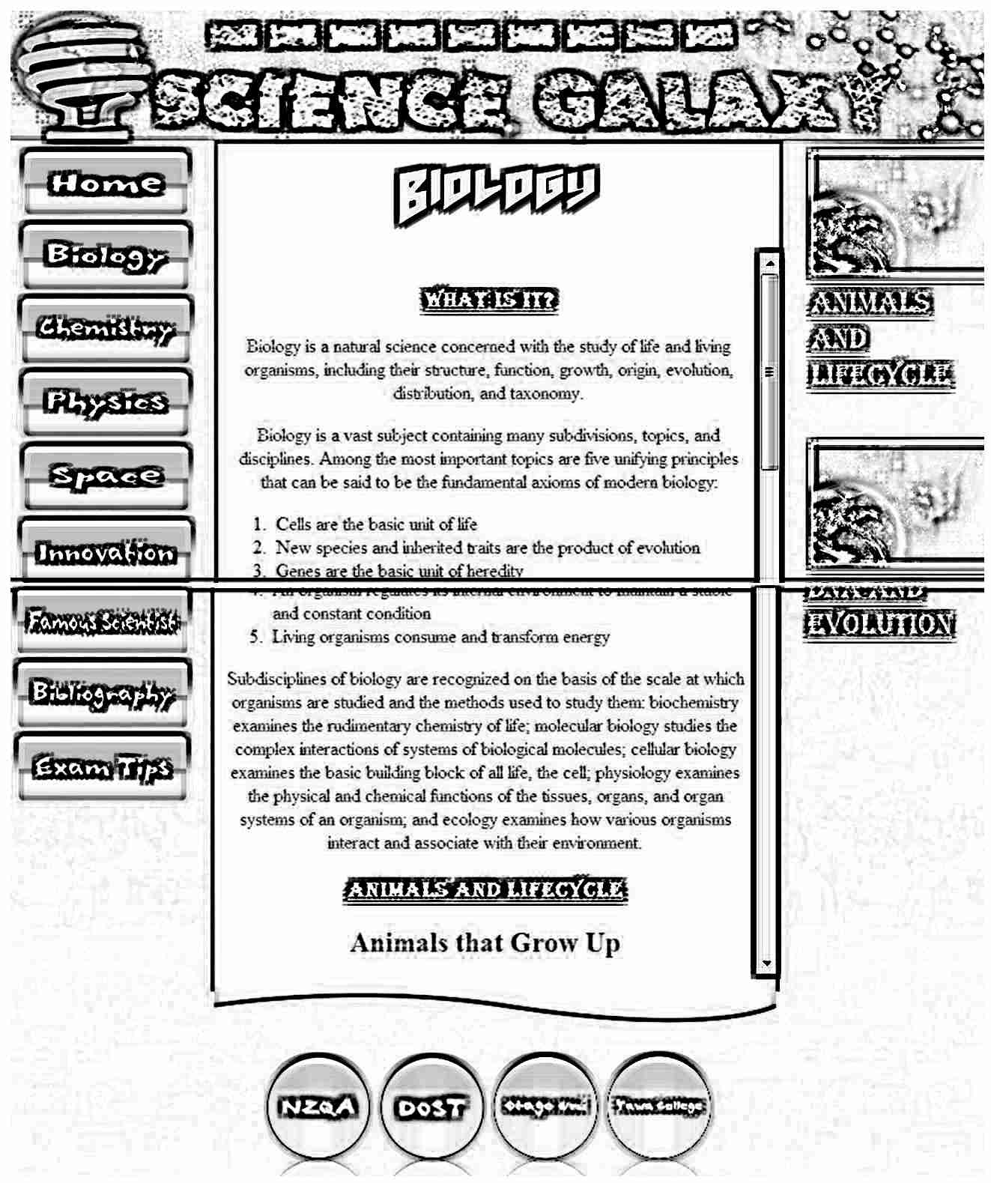
Website Banner
Babelfish, back:#006496, text colour: #fffff, 151x63, 55 px
Pandora limiter, 80px, #fffff
Algerian, 18px, #fffff, underline
Garamond, 16px, #000, auto content overflow
Babelfish, back:# 4169E1, text colour: #fffff, 175x245, 55 px, gel effect, glow on mouse-over

Background image: background.jpg (modern blue) like #006496.
‘Relevant pictures’
Picture size: At least 149 x auto
Algerian, 18px, #C5E9F5, underline
h2 elements: Garamond, 16px, #000
Algerian, 18px, #fffff, underline
#1C3259 background colour on main div. Medium solid border on main div

All h4 elements are subtopics of h2 elements, while h2 elements are subtopics of the main headings

All ‘h4’ and ‘tables’ elements and their paragraphs have an “h4_white” div tag – has white background. Garamond, 16px, #000

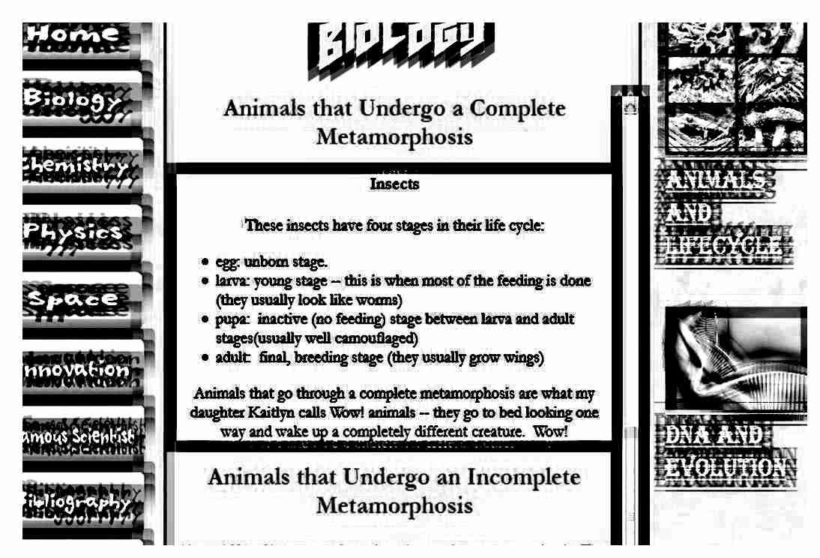

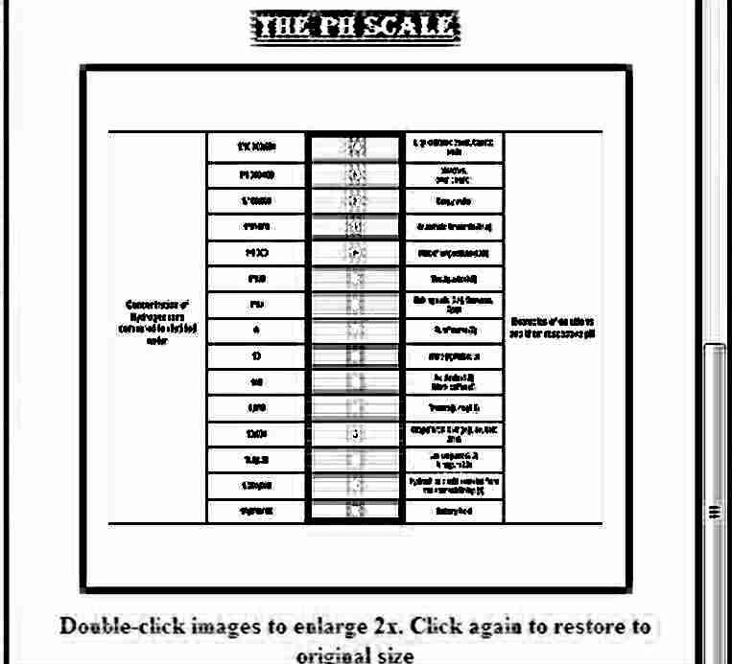
Second heading of chemistry page has a picture of PH Scale (360x345). All Images on the main div and subtopic div can be maximized 2x

